## Yogeek Shop Buy & Sell

#### Auto Translation.

Auto Translation functionality helps to automatic detect the language from UI and convert it as per user needed. For achieve this goal we are planning to use below techniques.

**Deep Translate**

Deep Translate is an API based service provider which translating plain text and

HTML documents between any of 100+ supported languages. No limits on request number or document length! and it’s also cheaper than google translate.

and also, it provides sandbox code of many languages.

**Pricing**

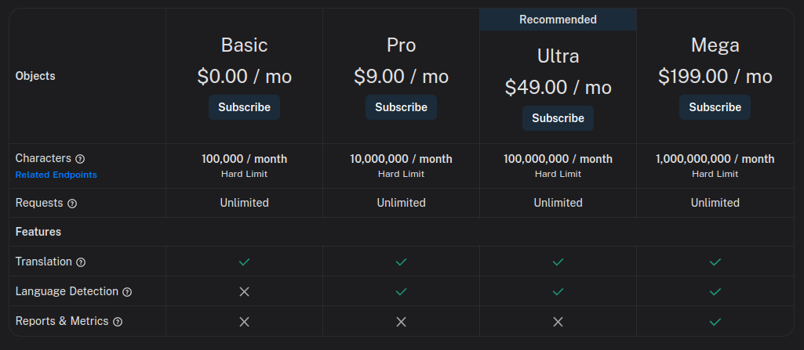

**Implementation flow**

**First, we need to set a default language for our front store.**

For implement this we should follow **Store** concept in which we need to add language module with all its functions.

At the time of Signup, we need to get users language by select or entering from user, and also stored this in **Store** also then we follow the language as default language of current user.

After that with the help of **Deep Translate** our language module’s function convert all the **UI**’s text to user’s default language.

And also we need to allow user to change his language through some where like setting or profile screen.

In **Chat** area we need to follow below steps

1. We need to get users message from there default language in chat area
2. By the help of our **language module,** we need to convert this to our

**Web Application’s** default language

1. Then we need to store this in **DB.**
2. At the time of message deliver we just need to convert the text from **DB** which is in set to our Web **Application’s** default language to the other user’s default language.
3. Using these techniques, we should maintain all text in one default language (Web **Application’s** default language).

#### Location Sharing

By using **Location Sharing** functionality one can easily track location of some one with the help of longitude and latitude. There are many service provider provide this service like, MapBox and Google.

But as per Google’s popularity we should go with Google’s Location API.

**Implementation flow**

At the time of registration, we need to capture the current users (Buyer and Sellers) Location automatically with the help of these APIs, then after we need to implement the feature in which we easily set user’s visible area (in KM).

Then every time when a Buyer or Sellers search something our application automatically created a dynamic map crated markers with listing the appropriate user,